Response NASA TLX PD
Actual by Predicted Plot
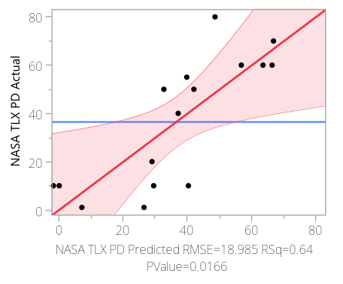

Effect Summary

Source | Logworth |  | PValue
Slouching scores Module 2 | 2.889 |  | 0.00129
Slouching scores Module 3 | 2.455 |  | 0.00351
Slouching scores Module 4 | 1.710 |  | 0.01950
Slouching scores Module 1 | 1.689 |  | 0.02048

Residual by Predicted Plot
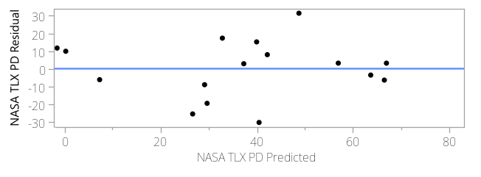

Studentized Residuals
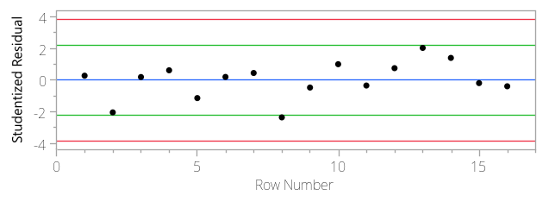

Externally studentized residuals with 95% simultaneous limits (Bonferroni) in red, individual limits in green.
Parameter Estimates

Term | Estimate | Std Error | t Ratio | Prob>|t|
Intercept | -22.70897 | 50.14632 | -0.45 | 0.6595
Slouching scores Module 1 | -2.034923 | 0.752309 | -2.70 | 0.0205*
Slouching scores Module 2 | 4.3616112 | 1.018101 | 4.28 | 0.0013*
Slouching scores Module 3 | -2.883978 | 0.779677 | -3.70 | 0.0035*
Slouching scores Module 4 | 1.3736066 | 0.502748 | 2.73 | 0.0195*

Prediction Profiler

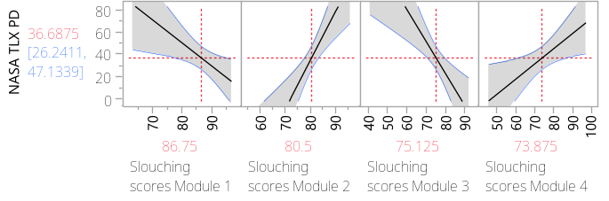

Response NASA TLX PD
Whole Model
Regression Plot
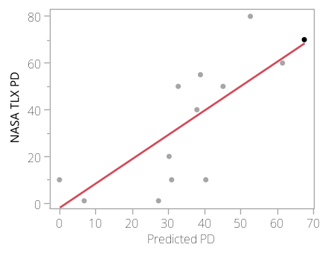

Actual by Predicted Plot
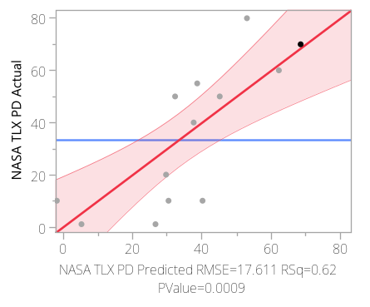

Lack Of Fit

Source | DF | Sum of Squares | Mean Square | F Ratio
Lack Of Fit | 11 | 3721.7306 | 338.339 | .
Pure Error | 1 | 0.0000 | 0.000 | Prob > F
Total Error | 12 | 3721.7306 |  | .
 |  |  |  | Max RSq
 |  |  |  | 1.0000

Residual by Predicted Plot
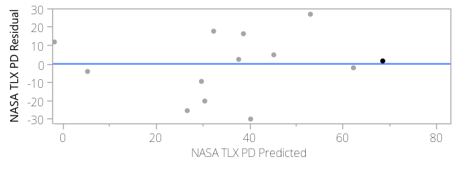
Summary of Fit

RSquare | 0.618253
RSquare Adj | 0.586441
Root Mean Square Error | 17.61091
Mean of Response | 33.35714
Observations (or Sum Wgts) | 14

Analysis of Variance

Source | DF | Sum of Squares | Mean Square | F Ratio
Model | 1 | 6027.4837 | 6027.48 | 19.4345
Error | 12 | 3721.7306 | 310.14 | Prob > F
C. Total | 13 | 9749.2143 |  | 0.0009*

Parameter Estimates

Term | Estimate | Std Error | t Ratio | Prob>|t|
Intercept | -1.774545 | 9.255309 | -0.19 | 0.8512
Predicted PD | 1.0424581 | 0.236468 | 4.41 | 0.0009*

Predicted PD
Leverage Plot
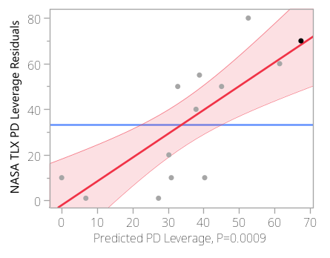

Correlation of Estimates
Corr

 | Intercept | Predicted PD
Intercept | 1.0000 | -0.8610
Predicted PD | -0.8610 | 1.0000

